
ESTATES STRATEGY

2012 - 2017

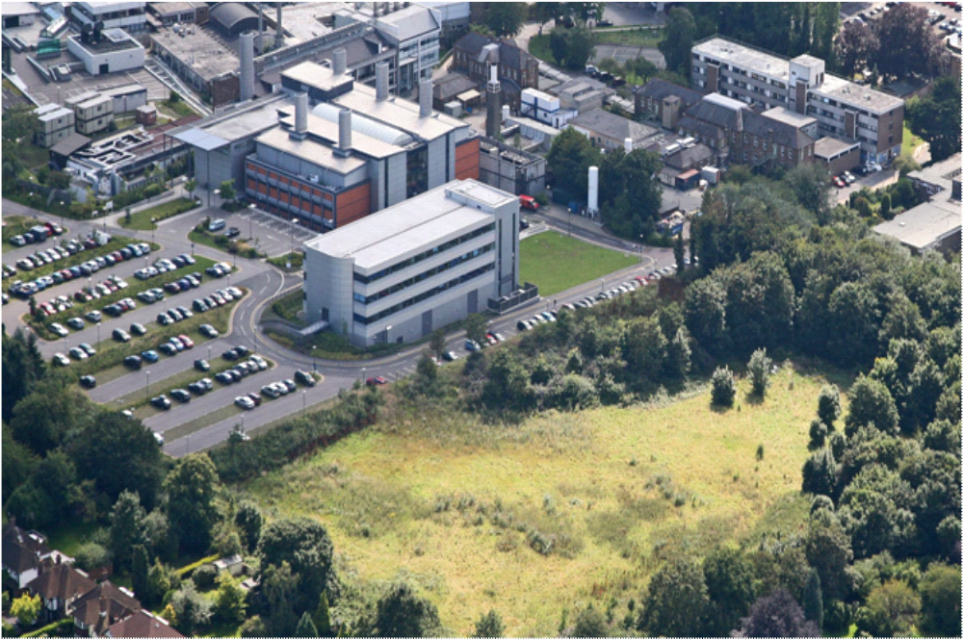

Contents Page No.

EXECUTIVE SUMMARY
- INTRODUCTION AND OVERVIEW
  - The Institute of Cancer Research 1
  - Estates Strategy 2
  - Existing Estate 2
    - Description, Location and Condition 2
    - Pollards Wood 8
    - Sutton Site Development 8
    - Future Site Needs 9

- PROGRESS AND ACHIEVEMENTS SINCE LAST STRATEGY
  - Previous Estates Strategy – Progress and Achievements 10
  - Estates Metrics 11
    - Tenure 12
    - Building Condition 13
    - Functional Suitability 14
    - Maintenance Costs 15

- STRATEGIC CONTEXT AND OBJECTIVES
  - Source and Reference strategies and documents 16
  - Scientific Strategy – Primary Source 17
  - The Strategic Plan 2007-2012 – Primary Source 17
  - Learning and Teaching Strategy – Primary Source 19
  - Carbon Management Plan 19
  - HR Strategy and documents 19
  - Risk Register – Secondary Source 19
  - Research Continuity Plan – Secondary Source 20

- STRATEGIC ESTATE OBJECTIVES
  - Purpose 21
  - Strategic Estate Objectives 21

Contents cont’d Page No.

- ESTATES PERFORMANCE ANALYSIS/GAP ANALYSIS
  - Gap Analysis 25
  - Future requirements and constraints 25

- IMPLEMENTATION OF THE STRATEGY….THE ACTION PLAN 26

- POLICIES AND PROCEDURES 32

- CONTROL MECHANISM – REVIEW AND REVISIONS TO THE STRATEGY 32

APPENDICES
APPENDIX A Estates Operational Structures
APPENDIX B HEFCE’s Estates Management Statistics Categories
APPENDIX C High Level Facilities Risk Register
APPENDIX D Reference Documents Bibliography

EXECUTIVE SUMMARY
This Estates Strategy identifies how the ICR estate will positively support the continuing growth and success of ICR, ensuring the estate is aligned with, can react to and supports the realisation of ICR’s Strategic, Scientific and Learning strategies. The over-riding purpose of the estate is to provide sustainable, cost effective, flexible and adaptable leading-edge research and teaching facilities.
The Estates Strategy covers a rolling 5 year period and should be considered a “live” document and therefore, subject to continuing review and revision. This update has been prepared as part of a major review of the last strategy version which was produced in 2007.
The key indicators of the status of the ICR estate are summarised as follows:
- Key plans and objectives identified in the last version of this strategy (2007) have been achieved
- ICR has achieved its objective of holding no residential accommodation
- Freehold property tenure has been maintained at the high level of 90%
- A Carbon Management Plan has been prepared to direct the planning of and management of the estate to ensure ICR maintains its responsibility to protect the environment and reduce its costs
- 100% of the estate is categorised as condition A or B as defined HEFCE indicators⁺
- Functionality of the estate is at 100% as defined by HEFCE estate indicators⁺
- This strategy recognises the need to continually review and monitor the flexibility and functionality of the estate through effectiveness of the existing space usage and seeking serendipitous opportunities for additional site acquisition or development of shared space with our partners.
The key Strategic Estates Objectives are on page 21.
The Estates Action Plan is on page 26.

⁺ For definitions of HEFCE (EMS) categories see Appendix B.
- INTRODUCTION AND OVERVIEW
1.1 The Institute of Cancer Research
The Institute of Cancer Research (ICR) is one of the world’s leading cancer research organisations and together with our partner; the Royal Marsden Hospital forms the largest Comprehensive Cancer Centre in Europe.
Our vision:
Is that people may live their lives free from the fear of cancer as a life threatening disease.
Our mission:
Is to relieve human suffering by pursuing excellence in the fight against cancer through:
- Research into the causes, prevention, diagnosis and methods of treatment of cancer
- Education and advanced training of medical and scientific staff
- Treatment and care of the highest quality for cancer patients
- Attraction and development of resources to the optimum effect.
Our goals:
- Goal 1 – Research and Impact
To be a world leader in fundamental research into cancer and the translation of research discoveries into improved outcomes for cancer patients
- Goal 2 – Education and Training
To educate and train the next generation of cancer researchers and clinicians
- Goal 3 – Environment and Infrastructure
To deliver a world class and sustainable organisation to support cancer research and education for patient benefit

All that we do is driven by a set of values, which reflect our mission.
Our values are:
- Research for Public Benefit – We are committed to carrying out cancer research that can be exploited to its maximum potential for the benefit of the public
- Excellence – We are committed to the pursuit of excellence in the fight against cancer. This encompasses every aspect of our work, research, education and all the supporting activities
- Integrity – We are committed to integrity, honesty and consistently high standards in all our dealings, both internally and externally
- Accountability – We believe that we are accountable for our actions to the public and to our funders, and we are prepared to submit ourselves to appropriate scrutiny
- Equity – We will ensure that our policies and practices do not discriminate unfairly or lead to other forms of unfair treatment.

The Institute operates from three sites, one adjacent to the Royal Marsden Hospital in Chelsea, London, a second some ten minutes walk from the Chelsea site, on the Old Brompton Road and a third it shares with the Royal Marsden Hospital, in Sutton, Surrey.
The Institute occupies a total of some 28,800m² (Gross Internal Area) of space. Much of the Estate is either new or has recently been refurbished. The Institute employs in excess of 1000 staff and students, approximately 400 of which work at the London sites.
  - Estates Strategy
This Estates Strategy identifies how the ICR estate will positively support the continuing growth and success of ICR, ensuring the estate is aligned with, can react to and supports the realisation of ICR’s Strategic, Scientific and Learning strategies. The over-riding purpose of the estate is to provide sustainable, cost effective, flexible and adaptable leading-edge research and teaching facilities.
Responsibility for the delivery of the Estates Strategy lies with The Deputy Director of Estates Services. The current Estates operational management structures are included in Appendix A.
The overall strategy is identified in terms of specific objectives and policies, with a commentary for each and identification of tangible methods of measurement.
The content and status of the existing estate is discussed together with progress against the objectives identified in the last Estates Strategy (revised in September 2007).
This strategy has been developed to cover a five-year period. Formal reviews will occur following any of the following key events:
- As a minimum every 12 months
- Whenever one of the primary sources identified in section 3 is updated
- Whenever external or internal drivers dictate
- A full and fundamental review in 2017 as the end of the period this strategy covers approaches
  - Existing Estate
    - Description, Location and Condition
ICR is located on three sites, two in Chelsea and one in Sutton, Surrey.
The following table gives overview details of the sites and buildings. The condition of each is rated using HEFCE’s Estates Management Statistics categories A-D and Functional Suitability categories – definitions are given in Appendix B.
All the sites are occupied on a sole occupancy basis. ICR also jointly occupies space for research within the Royal Marsden NHS Trust hospital premises at Chelsea and Sutton. This is unlikely to change within the period covered by this strategy. As the occupation attracts no liability to ICR, this accommodation is not included within the overall strategy.
Additionally ICR owns two areas of undeveloped land:
- Woodland and Agricultural land at Pollards Wood, Little Chalfont
- Development site to the north of the Sutton site.
TABLE 1 – Schedule of existing sites and buildings
Building | Function | Tenure | Age | Net useable floor area (m²) /Site Area (ha) | Condition previous strategy | Condition current | Comments | Functional Suitability
CURRENT PROPERTIES – FULHAM/CHELSEA
123 Old Brompton Road  Ground & Lower Ground Floors Zakhem House | Purpose built office/residential block with basement car parking.  Administrative office in Chelsea for Corporate Services including Finance, Fundraising, HR and Secretariat. | Leasehold from 17 Feb 1998 to 16 Feb 2023. Break clauses exist in lease. | N/A | 850 m2 gross | A | B | All in good condition but some problems with air conditioning and heating which are receiving attention. | 1
Glen House - 125 Old Brompton Road | Purpose built office/retail block.  Learning and Teaching facilities and associated offices. | Leasehold from 16 May 2008 to 17 Feb 2023. Break clauses exist in lease | N/A | 298 m2 | N/A | A | Refurbishment and new AC on occupation in Sep 2008. Service charge capped. | 1
Chester Beatty Labs  223-235 & 237 Fulham Road SW3 | Laboratories and associated facilities.  Multi-function science building with associated support functions. | Freehold | CBL 1960s, Extensive refurb 1999 | N&E 6,470m2  OLD 1,545m2 | B | B | Generally in good condition including decoratively. Basement and link toilets recently refurbished, inclusive of ancillary corridor improvements. Exterior and 3 floors of CBO recently refurbished. Ground floor corridor fire doors upgraded.
Chester Beatty Labs  Transformer Chamber lease | Transformer Room | Freehold – let to Electricity Board – 99 year lease | NA | NA | NA | NA |  | NA
CURRENT PROPERTIES – SUTTON
The Sutton site consists of a number of office and laboratory buildings of varying ages and conditions plus car parking and a large area of vacant land with development potential. |  | Freehold generally | N/A
Haddow Labs | Laboratories.  Laboratory building mainly occupied by Cancer Therapeutics. | Freehold | Built 1976 | 1,634 m2 | B | B | Internally refurbished over last 5 years. New boilers and AC units installed recently. Some exterior works required but all serviceable and covered by planned maintenance. Costs reviewed for replacement of windows and cladding in 2010 – costs excessive and currently impractical due to resultant disruption. Limited impact on users in existing state. | 1
CRUK - Cancer Research UK Building | Laboratories.  Chemistry Laboratories with some associated equipment/ rooms such as small-bore MRI and dark room. | Freehold | Built 1983 | 576 m2 | B | B | Internal refurbishment works undertaken during 2009 - 2010 inclusive of the provision of 3 new ducted fume cupboards. Remedial works undertaken to external roof mounted duct work. | 1
MUCRC  Male Urological Cancer Research Centre | Laboratories.  Laboratory building conducting research into Male Urological Cancers, e.g. testicular and prostate cancers. | Freehold | Built 2000 | 553 m2 | A | B | All in good condition and well maintained. Requires redecorating only. No impact upon operation. | 1
Brookes Lawley Building | Laboratories and support. Main Laboratory building in Sutton, multi-function science building with associated support functions including tertiary accommodation such as gym, canteen and lecture theatre. | Freehold | Built 2002 | 4,390 m2 | A | B | All in good condition and well maintained. | 1
Portacabins | Semi vacant portacabins | Freehold |  |  |  | B | Semi vacant portacabins. No reports of defective items from portacabin occupants and limited impact on current users. | 1
McElwain Labs | Laboratories.  Laboratory building mainly for Cancer Therapeutics. | Leasehold from Royal Marsden, 99 year lease, 66 years left. | 1966 | 852m2 | A/B | B | Main Lab areas refurbished in 2006. Exterior redecorated and new UPVC windows. Main roof replaced. All systems working with boilers replaced and chiller due for replacement 2011. | 1
Central Services Block | Old office building currently used for storage. Scheduled for demolition. | Leasehold | 1980’s | CSB  139 m2  Stores  129 m2  Solvent Store 31 m2  Storage  18 m2 |  | N/A | Building vacated October 2006 | N/A
Sir Richard Doll Building | Offices and write up.  Office Building for Epidemiology, Clinical Trials, Registry, IT, Facilities, Purchasing and HR | Freehold | 2005 | 2,841 m2 | A | B | All in good condition and well maintained | 1
ICR Cyclotron Facility, Erigal Radiopharmaceutical Production Unit, Royal Marsden NHSFT. | Radioisotope production facility/laboratories. | Leasehold 31 Aug 2010 to 20 Mar 2034.  Break clauses in lease |  | 400 m2 | A | A | All in good condition and well maintained. Space yet to be occupied | 1
Development site to north of BLB | Development site | Freehold |  | 3.17 ha |  |  | Outline planning permissions obtained in November 2009 for 3 new buildings (some 21,000m2) subject to conditions. Preliminary enabling works completed
CURRENT PROPERTIES – OTHER
Residential accommodation | The Institute no longer owns any residential accommodation, the buildings have already been disposed of in line with the previous agreed Estates Strategy.
Pollards Wood, Little Chalfont | An area of open fields and woodland owned by the Institute.  The woodland is in a green belt area and currently has no functional use. | Freehold |  | 15.97 acres |  |  | Potential development site subject to relaxation of planning regulations to allow change of use. Main benefit to ICR is in investment potential.

    - Pollards Wood, Little Chalfont – Near Amersham
ICR owns an area of Woodland and Agricultural land at Pollards Wood, located on the B4442 approximately 2 miles from Amersham and covers an area of approximately 15.97 acres. The site is within the Green Belt and currently does not contribute to the overall business objectives and strategy of ICR.
In its existing condition, the land’s value is purely as a woodland and agricultural site. In the short to medium term it is extremely unlikely that we would be able to increase its value by obtaining planning permission for change of use to residential use because the site is greenbelt. However, in the longer term the ability for the Local Authority to meet its housing allocation may lead to a relaxation or realignment of the green belt and enable us to realise a significantly increased value.
A valuation for ICR internal management purposes, compared the potential value of the land with the following results:
- Sold in its current condition as woodland £200-£275k
- Sold planning permission for residential development £8.4m – £10.9m
The land currently costs little to maintain and there are no rights of way across it. We therefore, continue to hold the land and review the following options annually:
- Do nothing
- Sell it as is
- Promote the site through the emerging Local Development Framework in an attempt to seek changes to the designation of the land through changes to planning policy and restrictions.
    - Sutton Site Development – North site
The vacant land on the north of the Sutton site has the potential to be developed and a planning application has been made to provide three new research and development buildings and associated facilities including parking.
The land previously had a planning designation for housing that originates from an application by the Royal Marsden Hospital to build houses upon it. ICR have successfully achieved change of use for this land from residential to health use following a rigorous consultation with local residents and the planning officers. The Local Development Framework now incorporates the changed land designation. We have outline planning permission for three new research and development buildings providing some 21,000 m2 of accommodation and associated parking

    - Future needs
The ICR Estate needs to be flexible and adaptable to react to the changing needs of the organisation and scientific strategies. This strategy will within all its activities, keep this need at the forefront of its planning and implementation and in particular:
- We will continually review serendipitous opportunities for appropriate acquisition of additional land or buildings at all sites.
- Continually audit existing space usage to ensure the effective and efficient use of all space available to ICR
- Continually support any partnership opportunities, which enable sharing of space in support of ICR’s objectives.
- Progress and Achievements since last strategy
  - Previous Estates Strategy – Progress and Achievements
The strategy is a “live” document and is subject to continuing review and revision. This current strategy should be seen as a continuation, development and evolution of a strategic plan that was started in 1994 and which was last revised in September 2007.
The great majority of the site-specific objectives set out in the last Estates Strategy have been achieved and the estate is now in a very good position to support the work of ICR into the future.
The previous Estates Strategy identified a number of projects to meet site-specific objectives that are listed below along with progress achieved to date.
TABLE 2 – Progress against Strategic Estates Plans since last strategy update

* Reference taken from table 3 - Strategic Estates Objectives - Estates Strategy 2007
* * reference taken from table 6.1 - Current Plans and Projects – Estates Strategy 2007

Location | Ref | SO Ref* | Pro Ref** | Project | Status
London |  | 5 | 11 | CBO Refurbishment - refurbishment of 4th, 5th and 6th floors. | Complete 2011
London |  | 5 | 4 | CBO Refurbishment - new lift and complete refurbishment of research accommodation on 1st, 2nd and 3rd floors | Complete 2009
Sutton |  | 5 | 9 | Completed refurbishment of Haddow Building (remaining areas) - ground and first floors | Complete 2009
Sutton |  | 7 | 6 | Developed Development Plan jointly with RMH - commenced Centre for Molecular Pathology | ICR due to occupy one floor from October 2012
Sutton |  | 4,7 | 7 | North Site development - achieved change of use designation, outline and detailed planning consent | November 2009
Chelsea |  | 7 |  | Network Biology Suite (integrated suite of High Performance Computing, Mass Spectrometry Laboratories associated support Laboratories) | Complete 2009
All sites |  | 6 |  | Server Upgrades at Chelsea and Sutton to facilitate the new High Performance Computing equipment; | Complete 2010
Chelsea |  | 8 |  | CBL Toilet Refurbishment | Complete 2011
All sites |  | 5, 7 |  | Completed various refurbishments to meet the changing needs of existing faculty and new faculty | Ongoing
Chelsea |  | 5 |  | Replacement of CBL Generator (500 KVA to 1000 KVA) | Complete 2011
Sutton |  | 5 | 9 | Relocation of old CBL Generator to support Haddow Laboratory. 2011 | Complete 2011
 |  | 5 | 9 | Replacement of (life expired) Haddow Fire Alarm Panel and associated infrastructure 2010/2011 | Complete 2011
Sutton |  | 5 |  | Completed project to provide 3 new fume cupboards in CRUK for new chemistry faculty | Complete 2011
Sutton |  | 5 | 11 | Refurbishment of McElwain Sutton including planned maintenance items (replaced chiller, AHU, Steam Plant). | Completed 2011
All sites |  | 9 |  | Obtained Salix Revolving Green Fund monies; ongoing carbon reduction projects using recycled funds from savings made. | On target. Ongoing
Management & Planning |  | 9 |  | Delivered Carbon Management Plan and Business Case for managing carbon. | Published March 11
Management & Planning |  | 2 |  | Estates Team developed a robust set of procedures for managing projects in line with ICR Financial Procedures, CDM and other legislation and best practice | Ongoing implementation
Management & Planning |  | 2 |  | Estates Team developed a bespoke web-based project management system in line with the above | Ongoing implementation
Management & Planning |  | 2, 6 |  | Ongoing Post Contract Questionnaires and Reviews for lessons learned and continuous improvement. | Ongoing implementation
Management & Planning |  | 7 | 1,2,3,11 | Estates undertook Benchmarking Space Review with peer group organisations (eg Sanger, Babraham etc). | Ongoing
All sites |  | 5 | 13 | Ongoing delivery of flexible and adaptable accommodation | Ongoing
Management & Planning |  | 8 |  | Maintenance Strategy Enhanced. | Draft strategy prepared
Management & Planning |  | 2 |  | Development of Professional Team; structured training plan and competency matrix | Ongoing implementation

In summary, the majority of the 2007 objectives have been achieved. Since the last strategy, ICR are now operating from an estate with almost 100% of its accommodation having been built new or refurbished since 1998 and with the majority of facilities being in condition category A or B. This rates us very highly when compared with other institutions as can be seen from the tables and graphs included within section 2.2.
Since the last strategy, a number of buildings have been reclassified from Condition A to B. However, this is as expected and acceptable as it reflects the criteria for category A that is limited to buildings up to 5 years old. As the estate age’s buildings will move from category A to B. The key factor is functional suitability, which remains high with most buildings fully within Grade 1.

2.2 Estates Metrics
The progress which has been made against previous objectives is evidenced by data available from the HEFCE Estate Management Statistics (EMS) returns. Key data as relevant to the ICR estate is provided below, extracted from the February 2011 revision of the EMS which relates to data up to 2009/10 but also reflects the current position.
    - Tenure
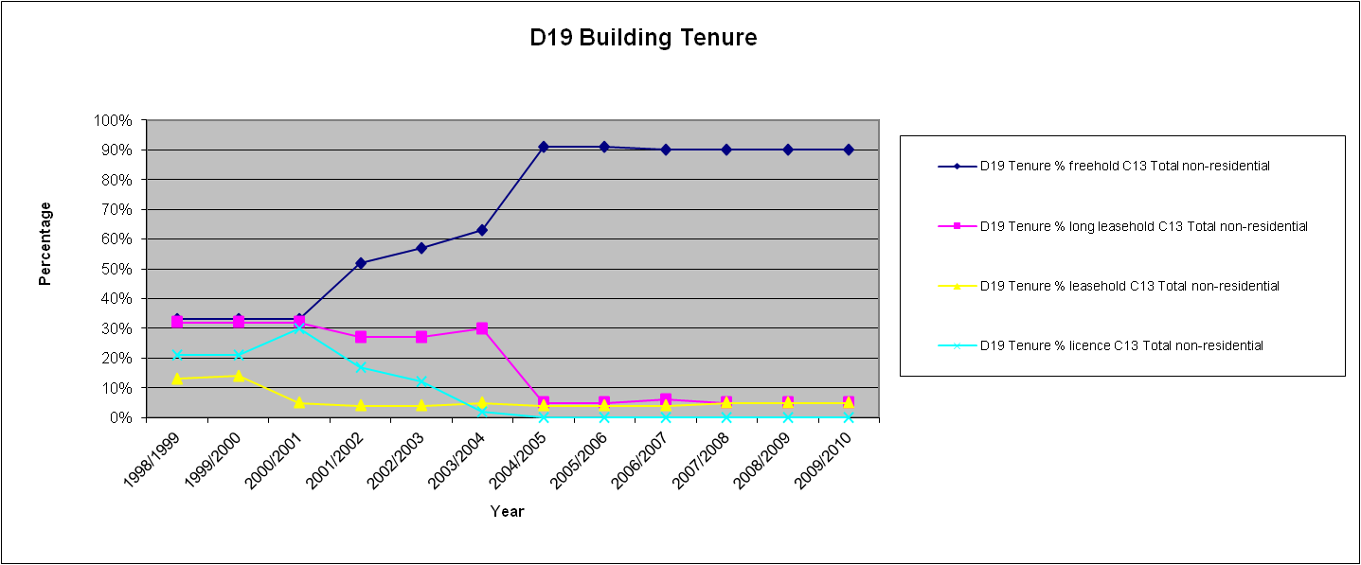
ICR maintains its objective of holding all properties on long term tenure (freehold or long lease) and this strategy aims to continue this position. Since the last strategy ICR has maintained its freehold estate at 90% with the remaining 10% being long leasehold office accommodation.

 | 1998/99 | 1999/00 | 2000/01 | 2001/02 | 2002/03 | 2003/04 | 2004/05 | 2005/06 | 2006/07 | 2007/08 | 2008/09 | 2009/10
D19 Tenure % freehold C13 Total non-residential | 33% | 33% | 33% | 52% | 57% | 63% | 91% | 91% | 90% | 90% | 90% | 90%
D19 Tenure % long leasehold C13 Total non-residential | 32% | 32% | 32% | 27% | 27% | 30% | 5% | 5% | 6% | 5% | 5% | 5%
D19 Tenure % leasehold C13 Total non-residential | 13% | 14% | 5% | 4% | 4% | 5% | 4% | 4% | 4% | 5% | 5% | 5%
D19 Tenure % licence C13 Total non-residential | 21% | 21% | 30% | 17% | 12% | 2% | 0% | 0% | 0% | 0% | 0% | 0%

2.2.2 Building Condition
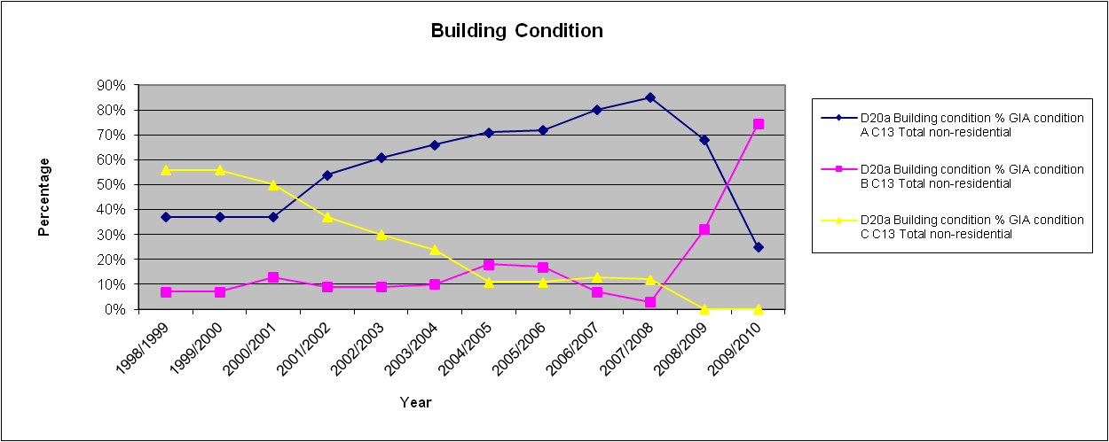
Buildings have been graded using HEFCE’s Estates Management Statistics categories A-D. The estate now has 25% of buildings classified as category A compared to 80% at the time of the last Estates Strategy. However, this reclassification is as expected and acceptable as it reflects the criteria for category A that is limited to buildings up to 5 years old. As the estate age’s buildings will move from category A to B. The key point to note is that the estate continues to comprise 100% Condition A and B buildings.

 | 1998/99 | 1999/00 | 2000/01 | 2001/02 | 2002/03 | 2003/04 | 2004/05 | 2005/06 | 2006/07 | 2007/08 | 2008/09 | 2009/10
D20a Building condition % GIA condition A C13 Total non-residential | 37% | 37% | 37% | 54% | 61% | 66% | 71% | 72% | 80% | 85% | 68% | 25%
D20a Building condition % GIA condition B C13 Total non-residential | 7% | 7% | 13% | 9% | 9% | 10% | 18% | 17% | 7% | 3% | 32% | 75%
D20a Building condition % GIA condition C C13 Total non-residential | 56% | 56% | 50% | 37% | 30% | 24% | 11% | 11% | 13% | 12% | 0% | 0%

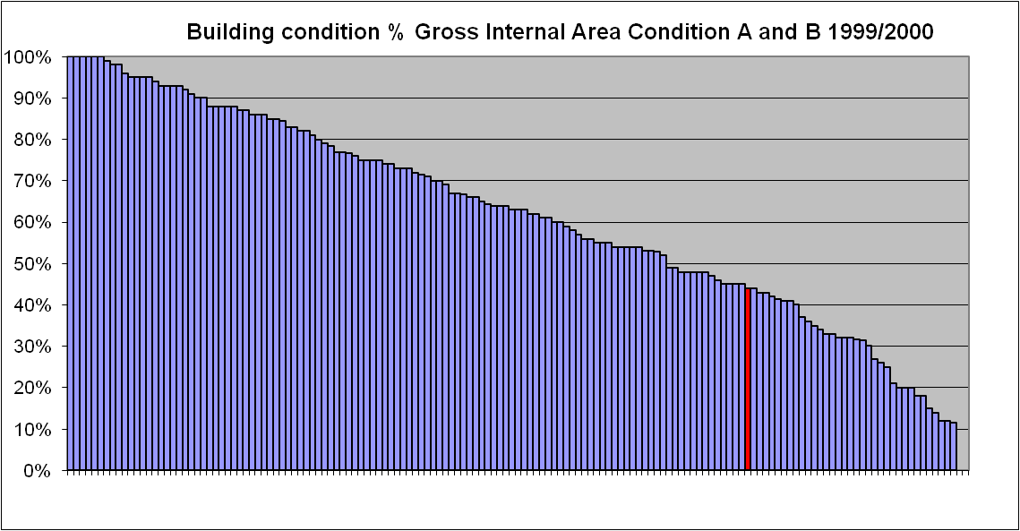
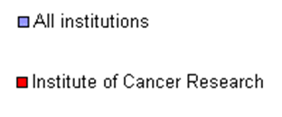

In 2007/2008 The Institute of Cancer Research ranked joint 30th out of 153 Higher Education Institutions for building condition. In 2009/2010 ICR is joint first.
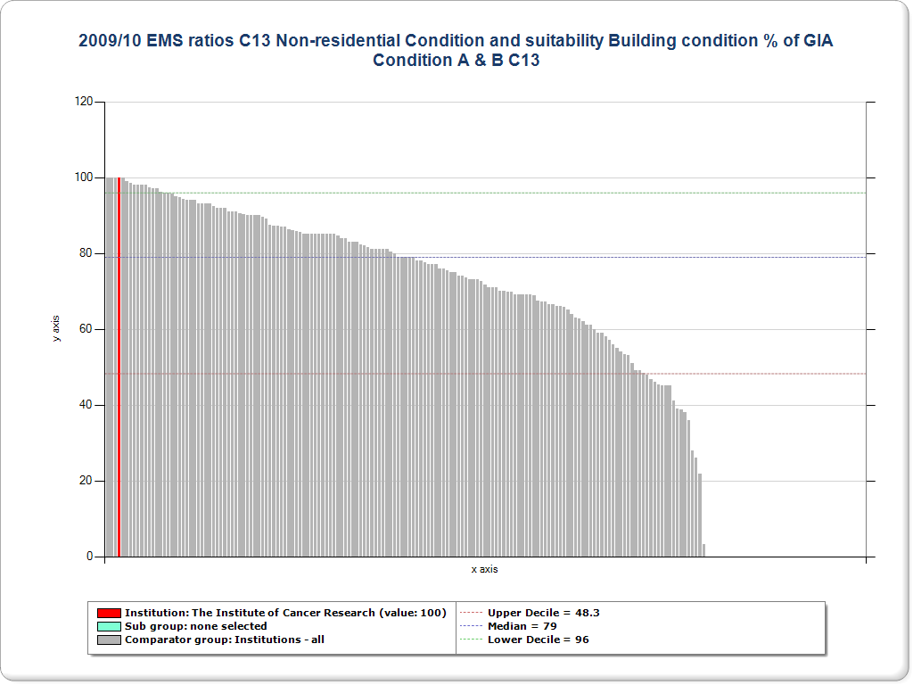

2.2.3 Functional Suitability The functional suitability of buildings is graded from 1-4 with 1 being the highest grade. ICR has maintained its standard of functionality with category 1 buildings now at 100% with the Institute maintaining is ranking as 1st out of 135 Higher Educational Institutes. In 1999/2000 the Institute was ranked 40th out of 120.
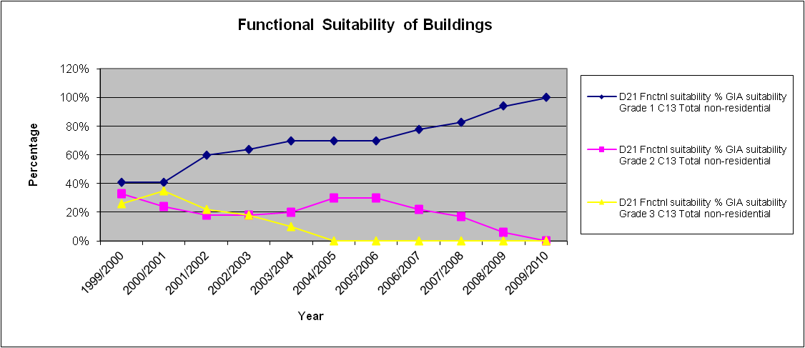

 | 1999/00 | 2000/01 | 2001/02 | 2002/03 | 2003/04 | 2004/05 | 2005/06 | 2006/07 | 2007/08 | 2008/09 | 2009/10
D21 Fnctnl suitability % GIA suitability Grade 1 C13 Total non-residential | 41% | 41% | 60% | 64% | 70% | 70% | 70% | 78% | 83% | 94% | 100%
D21 Fnctnl suitability % GIA suitability Grade 2 C13 Total non-residential | 33% | 24% | 18% | 18% | 20% | 30% | 30% | 22% | 17% | 6% | 0%
D21 Fnctnl suitability % GIA suitability Grade 3 C13 Total non-residential | 26% | 35% | 22% | 18% | 10% | 0% | 0% | 0% | 0% | 0% | 0%

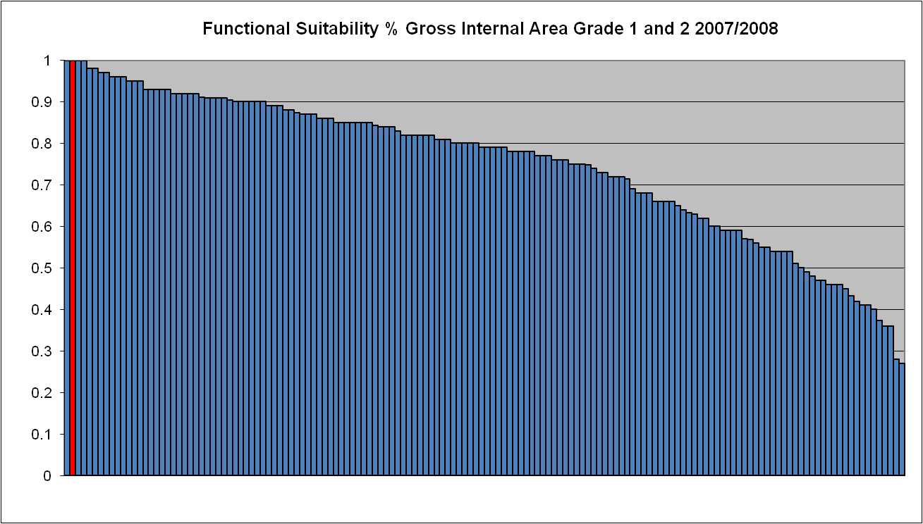

In 2007/2008 The Institute of Cancer Research ranked equal 1st out of 150 Higher Education Institutions on this measure and it remains equal 1st in 2009/10 rankings.
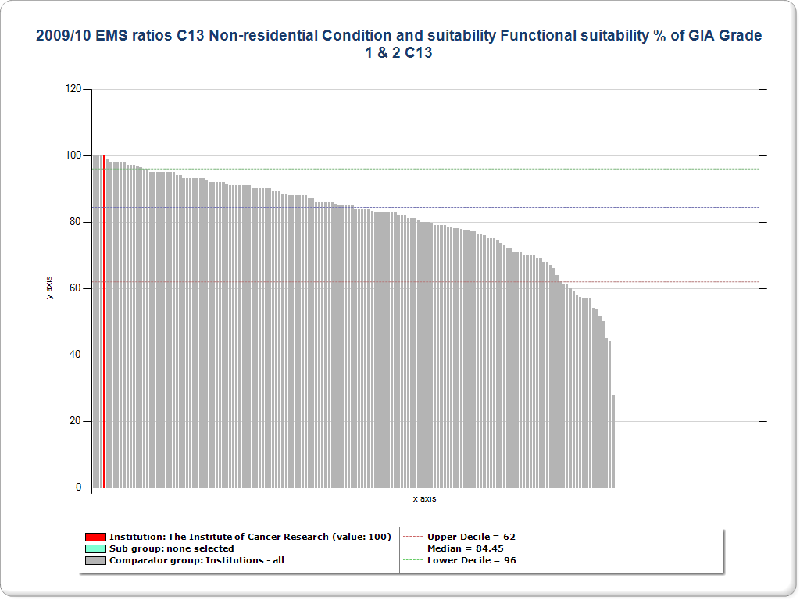

2.2.4 Maintenance costs
Since 2007, the amount of reactive maintenance has remained low compared with the planned maintenance. This trend has been achieved and maintained by the development of sustainable planned maintenance strategies with works implemented in a planned manner rather than reactively. This reduces disruption to the building users and enables improved budgeting.
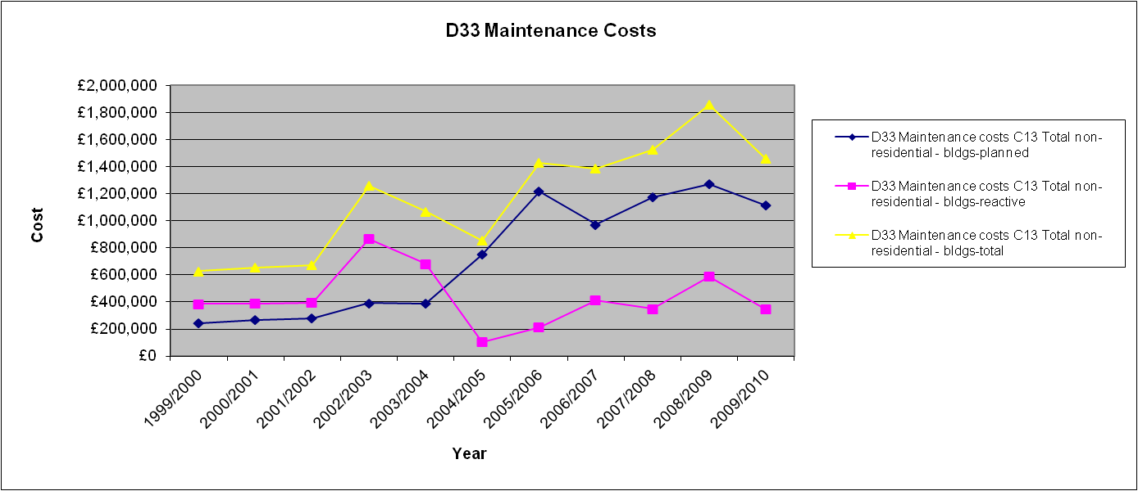

 | 1999/00 | 2000/01 | 2001/02 | 2002/03 | 2003/04 | 2004/05 | 2005/06 | 2006/07 | 2007/08 | 2008/09 | 2009/10
D33 Maintenance costs C13 Total non-residential - bldgs-planned | £241,522 | £267,945 | £279,376 | £391,384 | £386,988 | £752,661 | £1,217,092 | £972,845 | £1,173,942 | £1,273,695 | £1,114,811
D33 Maintenance costs C13 Total non-residential - bldgs-reactive | £385,341 | £387,585 | £395,200 | £866,267 | £681,998 | £103,228 | £213,209 | £411,567 | £349,763 | £586,407 | £344,579
D33 Maintenance costs C13 Total non-residential - bldgs-total | £626,863 | £655,530 | £674,576 | £1,257,651 | £1,068,986 | £855,889 | £1,430,301 | £1,384,412 | £1,523,705 | £1,860,102 | £1,459,390
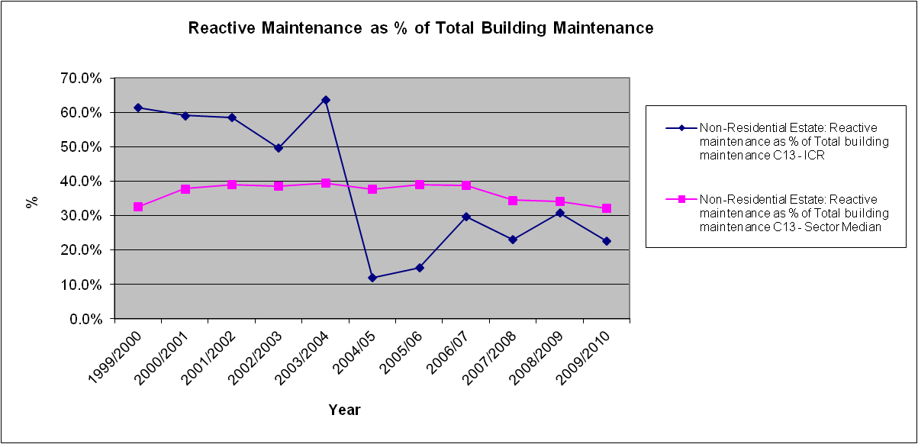

- Strategic Context and Objectives
  - Source and Reference strategies and documents
The Estates Strategy needs to complement and support the overall objectives and strategies of ICR.
ICR’s Vision, Mission and Values are set out in Section 1.
The way in which ICR will operate to meet its vision, mission and values is set out in a number of strategies. These strategies and plans are the primary sources upon which this Estates Strategy is formed. The Estates Strategy is to be reviewed each time one of these primary sources is revised:
- The Strategic Plan 2011-2016
- Scientific Strategy 2010-2015
- Learning, Teaching and Assessment Strategy.
- Capital Investment Framework Accreditation
- HEFCE capital investment guidance and programmes
Although the Capital Investment Framework Accreditation and the HEFCE capital investment guidance are not a strategy or plans specifically, both are key to the delivery of this strategy i.e. maintaining an understanding of the funding requirements and opportunities available through HEFCE allows development plans to be implemented and maintaining accreditation ensures funding can be readily obtained when available.
The following secondary sources have also been considered to determine the potential to impact on the Strategy:
- HR strategy and documents
  - Staff Attitude Survey (the most recent of which was completed in 2010)
  - Faculty Survey
- Carbon Management Plan
- High Level Risk Register
- Research Continuity Plan
The impact of revisions to these secondary sources will be considered only when the Estates Strategy is reviewed.
The primary output of the strategy is the ongoing review and development of the following:
- Maintenance Strategy and Plan
- Development Plans
- Structure of the Operational and Estates Groups which are predicated by the above – current structures are defined in Appendix A and will be reviewed further following approval of this strategy to ensure they fully meet the needs of delivery of the objectives

NB: The numbering of the key objectives drawn from the Primary and Secondary sources will be continuous in the following sections and are cross-referenced to the Estates Strategic Objectives in section 4.2. on page 21

  - Scientific Strategy 2010 – 2015 (Developing personalised medicine) – Primary Source
The Strategic Plan defines the scientific response to the organisations primary aims and goals.
The key objectives that inform and lead the Estates Strategy during the next five years are:
- Support the prioritization and allocation of accommodation and facilities to support the growth and maintenance of research activity
- Establish of the Centre for Molecular Pathology on the Sutton site in collaboration with the RMH.
- Provide capacity for experimental medicine around new drug development and clinical trials at both Chelsea and Sutton.
- Provide an infrastructure appropriate for High Performance Computing (HPC) essential to comply with NGS requirements and drug design, chemi-informatics, image analysis and network biology

  - The Strategic Plan 2007-2012 – Primary Source
The Strategic Plan defines the organisations primary aims and goals. The Estates Strategy seeks to support the Strategic Plan by forecasting need and demand and implementing a managed and sustainable plan to meet those goals whilst recognising the time lag that occurs in the physical development of infrastructure between the identification of need and the delivery of the solution.
Against each goal, the key objectives that inform and lead the Estates Strategy during the next five years are:
Goal 1 – Research and Impact
To be a world leader in fundamental research into cancer and the translation of research discoveries into improved outcomes for cancer patients
- To deliver accommodation and facilities that allows ICR to maintain its rating as the UK’S leading academic research centre
- Ensure an infrastructure is in place to allow the exploitation of collaboration and partnerships through strategic alliances with external parties.

Goal 2 – Education and Training

To educate and train the next generation of cancer researchers and clinicians
- To ensure appropriate consideration of space and facility needs of the postgraduate research, teaching and learning programmes
Goal 3 – Environment and Infrastructure
To deliver a world class and sustainable organisation to support cancer research and education for patient benefit
- To ensure all facilities are developed and maintained to the appropriate quality
- To ensure effective management and planning to attract funding to support the estate strategy objectives
  - Learning, Teaching and Assessment Strategy – Primary Source
The Learning, Teaching and Assessment Strategy defines the organisations response to the objective of ensuring the next generation of cancer researchers are appropriately educated and trained.
The key objectives that inform and lead the Estates Strategy during the next five years are:
- To provide appropriate facilities to support the expansion of the portfolio of postgraduate courses
- Support through the identification of appropriate facilities and infrastructure the challenges posed by teaching and learning on split sites
- Support through appropriate infrastructure the effective use of improved data management systems and techniques.
  - Carbon Management Plan – Secondary Source
The Carbon Management Programme supports ICR in its objective to reduce carbon emissions within its estate driven by compliance with legislation, financial benefit and maintaining reputation.
- The implementation of the programme of projects and improvements detailed in section 4 of the CMP
  - HR strategy and documents – Secondary Source
Although the HR strategy itself has little direct impact on the Estates Strategy, the HR staff surveys provide valuable feedback on the performance of the estate to deliver staff expectations. Therefore, references to these documents remain a key component of this strategy.
- Continue to review space needs and the quality of the environment to improve the differences in staff experiences between the sites
- Review the reasons behind the drop in staff satisfaction with the buildings and maintenance between 2007 and 2010 i.e. drop from 4.2 to 3.3, and implement mitigation
  - Risk Register – Secondary Source
A copy of the Facilities High Level Risk Register is provided in Appendix C. The key challenges for the Estates Strategy can be summarised by the following three key risks:
- Security. Ensure that the built environment promotes security of ICR and Staff.
- Inappropriate or inadequate space – caused by lack of adaptability/flexibility, lack of funding or changing legislation and/or regulation
- Maintaining continuity of research work following a catastrophic event

  - Research Continuity Plan (under development) – Secondary Source
ICR’s Research Continuity Plan is continually under review as new projects and facilities are created. Emergency Procedures have been in place for some time and have been tested. ICR has a Policy Statement for Emergency Response and Research Continuity, the following excerpts from the Research Continuity Plan impact directly on the Estates Strategy:
- In the event of an incident, staff safety and welfare will always be the first priority, followed by the security of the infrastructure and facilities in order that research and teaching activities can resume as quickly as possible.
- Strategic Estate Objectives
  - Purpose
The objective and purpose of the Estates Strategy is to identify how ICR’s estate will positively support the continuing growth and success of ICR. The specific demands placed upon the estate have been identified in the Section 3.
In addition to these specific demands, strategic estate objectives have been identified that define how the estate will be owned and occupied, developed, maintained and operated to act as a platform to support and propagate ICR’s objective.
In effect, these strategic estate objectives will serve as over-arching principles and an ongoing reference point: a long-term strategic framework.
  - Strategic Estate Objectives
The strategic estate objectives have been developed from consideration of the primary and source documents and those contained within the previous Estates Strategy, They are listed below together with the features and benefits of each and a commentary where applicable.

As far as possible these are measurable objectives and should not add to the administrative burden and should be readily available for “business as usual” data submissions such as the EMS (Estates Management Statistics) currently collected by ICR as part of the regular reporting requirements to HEFCE.

TABLE 3 - Strategic Estates Objectives

Note: References to Primary and Secondary Sources relate to key objectives identified in section 3 of this strategy.
SEO | Objective | References to Primary and Secondary Sources | Feature | Benefit | Commentary | Measurable
1 | To locate The Institute so that it may benefit from optimal interaction between centres of research excellence for basic science and for the treatment of cancer. | a, b | Existing sites are located in close proximity to Royal Marsden sites. Institute staff rub shoulders with clinicians, medical staff and patients. | Optimal interaction achieved. Visible and valuable “concept to cure” link. Co-operative working with clinicians and medical staff. | Additional development in Central London may test/stretch this objective due to availability of sites. | Actual locations compared to research and treatment partners’ locations.
2 | To provide an environment where the findings of basic research may be rapidly translated into clinical practice. | b, d, i | Modern state of the art & well maintained/serviced facilities located near or within accommodation that delivers clinical practice. | Fundamental to delivery of ICR mission. | Follow on, in effect, from objective 1 above. Difficult to measure due to its subjectivity. | Identification and early involvement of key stakeholders in the design process together, and analysis of Post Project Completion Questionnaires
3 | To encourage the integration of all sectors of The Institute by reducing the number of disparate buildings occupied and by providing a good working and social environment that will promote the productive interaction of all staff. | k, n, o | Easily navigable and interpretable site facilities and layouts.  Accessible, identifiable and attractive social hubs and cross-discipline informal interaction areas.  Strong corporate image/brand identity. | Improved delivery of Institute’s mission. Staff attraction and retention. Economies of scale for shared facilities. Lower support costs. | Pro-activity needed to empower staff to understand sites, layouts, function of areas and invite staff contribution to ongoing “refresh” of social areas.  Adjacencies to be reviewed. | Staff attraction and attrition rates. Staff perception expressed in Survey of Staff Attitudes.  Analyse student perception expressed in annual questionnaire and results of future staff surveys.
4 | To safeguard ICR future occupation of suitable accommodation by securing long term tenure of all our accommodation. | j, k | Accommodation is generally owned freehold or occupied on long term leases. | Secure basis for necessary levels of capital expenditure.  Ability to adapt/change accommodation without reference to third parties.  Staff retention. | The tenure or ownership of accommodation needs to be sufficiently flexible to allow The Institute to take advantage of potential “sale and leaseback” type opportunities. | Plan in place to review tenure of leased accommodation at least 48 months in advance of the end of the term and at least 18 months before each break or review milestone.
5 | To optimise the use of existing space available by providing accommodation that may be readily and economically adapted for different uses and opportunities as they arise. | c, f, g ,h | Space that is designed to be capable of being readily converted from one function to another or altered without major cost and without major disruption to existing operations. | Ability to react to ICR business needs to keep it at the forefront of research.  Value for money on a lifecycle basis (potential capital cost disbenefit). | Financial appraisal to be carried out for each new project to ensure that the balance between capital expenditure and future operating cost represents demonstrable value for money. | Value for money financial appraisal on a project-by-project basis.
6 | To accommodate ICR research and academic operations in facilities commensurate with modern research requirements and in compliance with applicable legislation and good practice. | d, c, i, l | Modern, generic, flexible and adaptable workspace. Future proofed design concepts. | Facilitates ability to deliver Institute’s mission.  Staff attraction and retention.  Ability to attract additional funding.  Safe working environment. | Consideration to be given to ongoing planned “refresh” programme to ensure that facilities do not become dated and stale over time. | Specific audits against required standards (e.g. GLP). Together with Identification and early involvement of key stakeholders in the design process together with analysis of Post Project Completion Questionnaires
7 | To provide, cost effectively and within the funds available, the optimum net usable floor areas to meet the needs of ICR research and academic activities, including accommodation for new initiatives and necessary support services. | e, j, k, i | Designs maximise net to gross floor areas. Designs are flexible and adaptable. Ensure plant space and service distribution space is reduced to a practicable minimum. | Fit for purpose workspace. | Value for money trade off between capital cost, future-proofing and optimisation of space to be considered carefully at appropriate project milestones. | Benchmark net to gross areas against previous projects carried out by ICR and also against new facilities constructed for other peer group organisations.
8 | To maintain all accommodation in suitable condition with due regard for its age and use whilst aiming to minimise recurrent expenditure on maintenance. | d, e | Planned and prioritised spend on maintenance and repair.  User Perception. | User perception.  Planned and controlled expenditure. Increased life of assets, safeguarding of capital invested. Low level of breakdown/disruption and need for emergency response. | 15 year forward-looking planned maintenance plan in place. This is reviewed annually. | Actual vs budgeted spend for planned and reactive maintenance budget.
9 | To minimise, by cost effective means, adverse sustainability influences that result from ICR estate. | m | Stated policy with tangible objectives identified. | Contributes to Corporate Social Responsibility (CSR) agenda at a number of levels. Potential for reduced primary energy costs per sq. metre. Attractive to potential funders. | Continually review and update Carbon Management Plan, Environmental Policy and Environmental Management Systems. | Develop KPIs for sustainable/environmental issues that demonstrate performance and ongoing improvement, both for The Institute as a whole and on a project-by-project basis.

The following objective within the previous Estates Strategy has been achieved:

- To hold no residential accommodation – ICR currently holds no residential accommodation
5.0 estates performance analysis/GAP ANALYSIS
  - Gap Analysis
Having reviewed the information regarding business need, status of existing accommodation and projects that are in hand, this Estates Strategy has considered where the existing estate was not able to support the stated business objectives leading to a gap analysis with options provided as to how to eliminate the gap.
As can be seen in previous sections the completed, progressing and planned projects have already gone a long way in meeting the Estates Objectives and this can be further evidenced within the EMS reports, which quantify the progress that has been made.
This Estates Strategy has therefore, set out an Action Plan (see section 6) to ensure the continued implementation of the plans to meet the known requirements of the business.
There are currently no significant gaps in the needs of the business and the accommodation and facilities available to deliver that need.
  - Future Requirements and constraints
The strategy will be kept continually under review in order that it can adapt to meet changing need and priorities as they become apparent.
To accommodate future changes, the estate must remain flexible and adaptable. Work is continuing on the key interrelated strategic options that face ICR in the next period, namely:
- Options for the serendipitous expansion of the London research site
- Development of the North Site at Sutton, collocating all staff

The major constraint to progressing any of the major expansion plans is funding. The availability of future funding from private and government sources (e.g. Welcome Trust, SRIF, etc.) or from ICR Fundraising will dictate the speed and progress of expansion plans.
The secondary constraint is the lack of available land or accommodation in the immediate locality of our sites in London.

- IMPLEMENTATION OF THE STRATEGY….THE ACTION PLAN
The estates performance analysis has not identified any significant gaps in this Estates Strategy to meet the needs of the needs of the science other than that of sufficient funding. Allied to this are the associated provisions and policies which will enable the Estate to be managed in the most effective manner whilst meeting the Institutes Objectives and legislative requirements.
The following table details all the projects in an annualised action plan for the period covered by this Estates Strategy. Each project is prioritised as either:
  - Immediate requirement
  - Medium term requirement
  - Longer term requirement
The Estates Strategy is a “live” document and internal and external drivers could dictate that projects and priorities change and the control mechanism for change is described in Section 8.
ICR maintain a strategic risk register. This register is updated on a regular basis and identifies risks to the Institutes Strategic Objectives and will be fed back into and inform the Estates Strategy.
Specific risk registers will be developed as a management tool for each individual project and will be updated as the projects progress. These will also feed back into the Estates Strategy. A High Level Estates Risk Register is in Appendix C.
The annualised plan is based on pro-active planning based on an assumed level of funding. This can be revised as necessary as funding is confirmed. This is the new HEFCE proposal and is a change from previous funding procedure which was reactive waiting for funding to be confirmed before proceeding with the project.
ICR provide estate management statistics which enable HEFCE to monitor performance and also enable the ICR to benchmark themselves against the HE sector.
TABLE 4 – Current Strategic Estates Action Plan
Item | Option/Proposal | Priority | 2012 | 2013 | 2014 | 2015 | 2016
1 | Purpose built facility for Molecular pathology (Biomedical Research Building) located in Sutton | 1 | Complete Construction and complete occupation of the building.
2 | New Research Accommodation in Chelsea to increase capacity | 2 | Continue to monitor opportunities for potential expansion and refurbishment. | Continue to monitor opportunities for potential expansion and refurbishment. | Continue to monitor opportunities for potential expansion and refurbishment. | Continue to monitor opportunities for potential expansion and refurbishment. | Continue to monitor opportunities for potential expansion and refurbishment.
3 | Construct Phase 2 of Richard Doll building (The Centre for Cancer Imaging) at Sutton | 1 | Complete Detailed Design for the Building. Commence Construction. | Construction Continues. | Complete Construction, Validation and Commissioning. Commence occupation of the Building.
4 | Additional Research Accommodation at Sutton  Masterplan of Sutton Site.  Development of 3 Research Buildings on North Site Land at Sutton. | 2 | Continue to liaise with other stakeholders of the Sutton Site (NHS, RMHNHSFT, Epsom & St. Helier etc). Monitor and review opportunities for collaboration or acquisition.  Commence preliminary design of North Site Building 1 Drug Discovery Facility including Chemistry. | Commence detailed design of North Site Building 1. | Submit detailed (full) planning application and discharge planning reserved matters for North Site Building 1.  Commence preliminary design of North Site Building 2 (undefined research facility). | Commence construction of North Site Building 1.  Commence detailed design of North Site Building 2. | Continue Construction of Building 1.  Submit detailed (full) planning application and discharge planning reserved matters for North Site Building 2.
5 | Demolish and Replace Existing single storey CRUK building with larger research facility. | 3 | Reliant at this time on programme for providing new chemistry decant accommodation as part of North Site development (item 4 above) prior to demolition and redevelopment. |  | Commence feasibility Study and options appraisal to RIBA Stage C for the demolition and redevelopment of the CRUK Building. | Commence preliminary design to RIBA Stage D/E for replacement of CRUK building. | Commence detailed design for replacement of CRUK building.
6 | Vacate McElwain Laboratory Building | 3 | Reliant at this time on providing replacement accommodation as part of works under item 3 | Consider options for potential re-use of McElwain for freezer storage or return to RMH. | Potential vacation of McElwain Laboratory following completion of SRD extension.  Potential re-use of McElwain for freezer storage or return to RMH.
7 | Demolish Central Services Block | 1 | Undertake feasibility study on relocation of critical services terminating in CSB and containment of critical services beneath. | Relocation or containment of services, stripping out redundant services.  Demolish remainder of Central Service Block (dependent upon plans for the use of McElwain).
8 | Continue to deliver, monitor and implement environmental policy and carbon reduction projects as part of ICR Carbon Management Plan and Eco Campus targets and initiatives. | 1 | Ongoing | Ongoing | Ongoing | Ongoing | Ongoing
9 | Continue to review all space requirements and allocations throughout ICR’s Estate. | 2 | At Strategic Space Committee Meetings. | At Strategic Space Committee Meetings. | At Strategic Space Committee Meetings. | At Strategic Space Committee Meetings. | At Strategic Space Committee Meetings.
10 | Review the Institutes Estates Risk Register. | 1 | Quarterly | Quarterly | Quarterly | Quarterly | Quarterly
11 | Annual Estates Strategy Review. | 1 | Annually | Annually | Annually | Annually | Annually
12 | Fundamental Estates Strategy Review in response to any strategic changes or every 5 years minimum. | 3 | Interim | Interim | Interim | Interim | Fundamental Quinquennial Review
13 | Post Project Completion Questionnaires on all projects over £250k. | 1 | Ongoing | Ongoing | Ongoing | Ongoing | Ongoing
14 | Review of 123/125 Old Brompton Road Tenure | 3 | Undertake review at least 12 months prior to lease break clause in 2013. |  |  |  | Undertake review at least 12 months prior to lease break clause in 2018.
15 | Benchmark against sector metrics | 1 | On completion of annual EMS sector Survey and through Estates Team own benchmarking activities. | On completion of annual EMS sector Survey and through Estates Team own benchmarking activities. | On completion of annual EMS sector Survey and through Estates Team own benchmarking activities. | On completion of annual EMS sector Survey and through Estates Team own benchmarking activities. | On completion of annual EMS sector Survey and through Estates Team own benchmarking activities.
16 | Analyse Student and Staff perception surveys through Annual Satisfaction Surveys. | 1 | At time of survey/s | At time of survey/s | At time of survey/s | At time of survey/s | At time of survey/s
17 | Annual Review of 15 Year Maintenance Plan (current plan developed for years 2011 to 2026) | 1 | Annual | Annual | Annual | Annual | Annual

- POLICIES AND PROCEDURES
Allied to the projects detailed in the previous section are the associated policies and procedures, which will enable the estate to be managed in the most effective manner whilst meeting ICR objectives and legislative requirements.
Appendix D identifies the existing and required policies and procedures that are necessary to operate the estate as follows:
- Energy and Environmental Policy
- The Carbon Management Plan
  - Ecocampus Scheme
  - Environmental Management System
- Maintenance Strategy
- Disabled Access
- Research Continuity Plan
- Space Management
- Institutes Strategic Risk Register
- Facilities Risk Register

- Control Mechanism – Review and revisions to the strategY
As part of ICR’s business planning process the Estates Strategy will need to be reviewed formally on a regular basis and updated as necessary. The control process for this is described below.
Control
- This Estates Strategy is owned by the Deputy Director of Estates Services.
- The Estates Strategy is considered and approved by the
  - Director of Operations,
  - Operations Board,
  - Executive Strategy Board
  - Investments & Building Development Committee,
  - Board of Trustees.

The Estates Strategy will be reviewed and revised as necessary under the following circumstances:
Time-Based – reviews by Director of Operations and Deputy Director of Estates Services
- Annually – general review – to include a review of any secondary sources that have changed or been reviewed in the previous year period
- Every five years – fundamental review.
Event-Based
- When a Primary source is changed or reviewed (or first introduced in the case, for example, of the Research Continuity Plan
- When dictated by the management board, due to a specific event or occurrence including both internal and external drivers, for example:
  - New or significantly altered scientific driver
  - Availability of funding
  - New legislation
  - Revisions to HEFCE guidelines.
Once a change has been identified which requires the Estates Strategy to be updated the revisions will need to be recorded and approved.

APPENDIX A
Existing Estates Operational Structures
(under review)

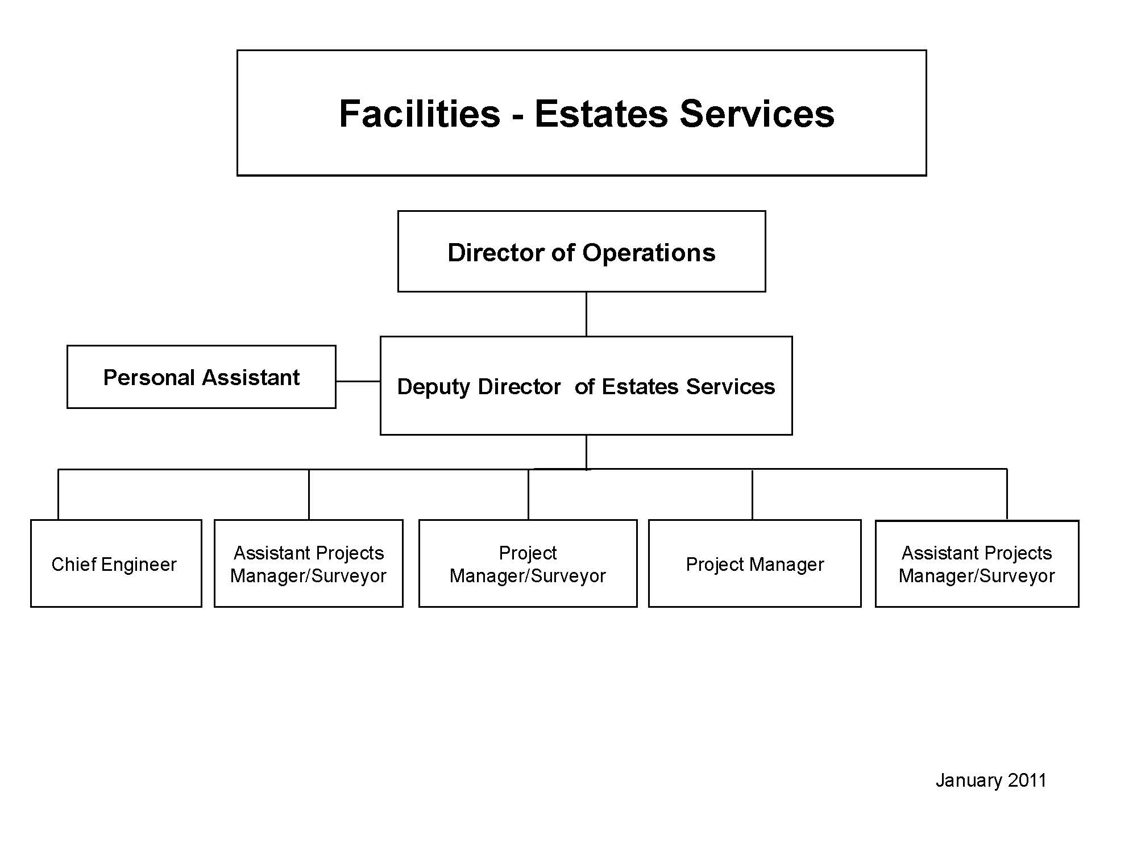

APPENDIX B
HEFCE’s Estates Management Statistics categories
All buildings have been identified in Table 1 and the condition assessed and categorised using HEFCE’S Estates Management categories as below
Building Condition
A - As new condition.
Features one or more of the following: Typically built within the last 5 years, or may have undergone a major refurbishment within this period. Maintained / serviced to ensure fabric and building services replicate conditions at installation. No structural, building envelope, building services or statutory compliance issues apparent. No impacts upon operation of the building.
B - Sound, operationally safe and exhibiting only minor deterioration.
Typically features one or more of the following: Maintenance will have been carried out. Minor deterioration to internal / external finishes. Few structural, building envelope, building services or statutory compliance issues apparent. Likely to have minor impacts upon the operation of the building.
C - Operational, but major repair or replacement needed in the short to medium term (generally 3 years).
Typically features one or more of the following: Requiring replacement of building elements or services elements in the short to medium term. Several structural, building envelope, building services or statutory compliance issues apparent, or one particularly significant issue apparent. Often including identified problems with building envelope (windows / roof etc.), building services (boilers, chillers etc.). Likely to have major impacts upon the operation of the building, but still allow it to be operable.
D - Inoperable, or serious risk of major failure or breakdown.
Building is inoperable, or likely to become inoperable, due to statutory compliance issues or condition representing a health and safety risk or breach. May be structural, building envelope, or building services problems coupled with compliance issues. The conditions are expected to curtail operations within the building. Exclude very minor items, which can be rectified easily.

Functional Suitability
Functional suitability measures the capability of the space to support its existing function. If the space is vacant, the indicator will assume the last use of that space. If space is temporarily vacant (e.g. due to refurbishment), the same assumption applies.
Grade 1 Excellent - the room(s) / building(s) fully support current functions. There are no negative impacts upon the functions taking place in the space. (The space is highly suitable for current functions).
Grade 2 Good - the room(s) / building(s) provides a good environment for the current function in all or most respects. There may be shortfalls in certain areas, but these have only a minor effect upon current functions. (The space is suitable for current functions).
Grade 3 Fair - the room(s) / building(s) provides a reasonable environment for current functions in many respects, but has a number of shortfalls. These shortfalls may be causing mismatches between space and function that is having a more significant effect upon current functions than Grade 2 rooms. (The space is generally unsuitable for current functions).
Grade 4 Poor - the room(s) / building(s) fail to support current functions and/or are unsuitable for current use. The operational problems associated with such space are major, and are constraining current functions in the space. Space in this grade may require alternative solutions, rather than straightforward improvements in particular features of the space. (The space is very unsuitable for current function).

APPENDIX C
High Level Risk Register


FACILITIES

Risk Register

High Impact Risk Register

All High Level Risks from the following Risk Registers are incorporated within this document:

- BSU
- Estates Risk Register
- Emergency Risk Register
- Individual Project Risk Register

Key: Type of Risk: Scientific )
Financial ) High Level
Operational )
Facilities - Estates Service / Facilities Services / Purchasing / All

Guide valuations for impact and likelihood are as follows:

Impact |  | Low | Medium | High
 | Financial Impact (across whole Institute) | < £100k | £100k to £500k | >£500k
 | Impact on Reputation/Image | Local | National | International
 | Operational Impact | Minor inconvenience | Inhibits achievements of strategic objectives | Prevents achievements of strategic objectives
Likelihood |  | Low | Medium | High
 |  | Low likelihood | Possible likelihood | High likelihood

Risk | Type of Risk | What is the risk? | Contributing factors | What actions should be taken to mitigate  the risk? | Are there any early warning mechanisms to monitor? | Impact | Likelihood | Contingency | Owner
 | Operational  Facilities  (Estates Services) | Lack of sufficient laboratory and office space | - Lack of resources – money land etc.  - In appropriate use of space. | - Comply with planning conditions and Section 106 notice on land to North of SRDB,  - Continuous review of space by SSMT. | - Failure to raise money for proposed new buildings north of SRD  - Continuous review of space. | H | M |  | Director of Operations
 | Operational  Facilities  (All) | All or part of The ICR is unable to function due to catastrophic event | - Loss of space, equipment, facilities services or people due to fire, flood or major incident | - Continuous review & update Research Continuity Plans  - Policies and procedures written for all services detailing how to keep ICR working  - Staff Awareness & training  - Business dependency modelling and plans being produced for Scientific Divisions  - Continual review of detailed risks at Emergency Preparedness Committee | - Automatic detection systems.  - Monitoring external environment & Intelligence. | H | M | - Emergency procedures in place.  - Research Continuity Plans in place for services | Director of Operations
 | Operational  Facilities  (Estates Services) | Unable to resolve competing space needs with The Royal Marsden NHS Foundation Trust | - Both organisations driven by different priorities and sponsors | - Regular meetings between CE’s  - Strategic Space Management Meetings to agree priorities for space  - Joint Planning of the CMP |  | H | L | - Increase the ICR building programme | Head of Clinical Laboratories/  Director of Operations
 | Operational  Facilities  (Facilities Services) | Lack of regulatory Health & Safety, compliance | - Ineffective training and communication of requirements  - Lack of compliance with policy and procedures by staff/student | - Regular updating of policy/guidance  - Regular audit by Health Safety & Environment Service  - Maintaining OHSAS 18001 accreditation including training  - Complete Ecocampus initiative.  - Continued review of detailed risks at Emergency Preparedness Committee. | - Improvement notices from statutory bodies  - Failure to maintain OHSAS accreditation | H | L | - Energy Procedures & Research Continuity Planning | Chief Executive/  Director of Operations /  Deputy Director Facilities Services
 | Financial  Facilities  (Estates Services) | Impact of Government Legislation to reduce Carbon Emission and associated costs | - HEFCE monitoring against 2005 baseline  - CRC legislation attempting to reduce carbon footprint of large organisations | - Implementation of Carbon Management Plan  - Pay for Carbon use  - Complete energy efficiency projects  - Complete Ecocampus initiative  - Utilise funding opportunities to fund carbon saving initiatives | - EMS Statistics  - Regular review at Energy meetings. | H | M |  | Director of Operations/ Deputy Director Of Estates Services
 | Operational  Facilities  (Facilities Services) | Major security breach | - Changes in external drivers | - Security working group to regularly review risks  - Liaison with external security advisors  - Desktop exercises including the above to be undertaken regularly. | - External security advisers to give regular updates.  - Monitoring of external environment & intelligence. | H | L | - Implement Site Security Plan | Director of Operations/ Deputy Director Facilities Services
 | Operational  Facilities  (Facilities Services) | Human health  Pandemic |  | - Monitor press and HPA website.  - Update Pandemic plans. | - Monitor WHO site. | H | L | - Pandemic plans in Corporate Services | Director of Corporate Development & Planning /  Director of Operations /Deputy Director of Facilities Services
 | Operational  Facilities  (All) | Loss of Essential / critical Services / Communi  cations,  (Gas, water, power, drainage, LN2 supplies etc.) | - Local or regional failure of supplies/services. | - Continual update of emergency procedures and Research continuity plans.  - Regular review at Emergency Preparedness and Research Continuity Meetings. | - Monitoring external environment. | H | M | - Implement Research Continuity plans. | Director of Operations
 | Operational  Facilities  (All) | Loss of operational ability due to outside influences. (strikes, Olympics, restriction of access). | - Outside influences. | - Continual update of emergency procedures and Research continuity plans.  - Regular review at Emergency Preparedness and Research Continuity Meetings. | - Monitoring of outside influences.  - Liaison with LOCOA | H | M | - Implement BC Plans | Director of Operations
 | Financial  Facilities  (Estates Services) | Financial.  Lack of funds for expansion of estate. | - Reduction of funding from external sources. | - Develop funding strategies and make bids to appropriate sources. | - Monitor external environment. | M | M | - Delay works or suspend activities whilst maintaining relevant approvals to plans (e.g. planning permission). | Deputy Director of Estates
 | Financial  Facilities  (Estates Services) | Financial.  Lack of funds for refurbishments. | - Reduction of funding from external sources | - Develop funding strategies and make bids to appropriate sources. | - Monitor external environment | M | M | - Delay works while maintaining relevant approvals to plans (e.g. planning permission). | Deputy Director of Estates
 | Financial  Facilities  (Estates Services) | Financial.  Lack of funds for maintenance. | - Reduction of funding from external sources | - Continually review 15 year maintenance plan. | - Monitor external environment | H | M | - Reprioritise works and smooth impact over time. | Deputy Director of Estates
 | Financial  Facilities  (All) | Increase in tender/contract/utilities prices. | - Inflation or tax increases. | - Continually review market and procurement strategies.  - Continually monitor contract performance. | - Monitor external environment | H | H | - Reduce size or number of projects/contracts/services to meet budget. Reduce levels of services required. | Director of Operations
 | Operational  Facilities  (All) | Adverse changes in legislation | - Changes in external environment | - Monitor proposals via professional bodies’ updates and specialist press (e.g. BIFM, RICS, HEFCE etc). Take part in consultation process.  - Maintain legislation register and communicate to business. | - Monitor professional bodies and specialist press. | M | M | - Plan for consequences and revise documentation accordingly. | Director of Operations
 | Operational  Facilities  (All) | Internal skills shortage. | - Changes in support requirements from customers.  - Changes in external drivers – legislation. | - Develop in house staff with both academic and professional training. | - Monitor professional bodies and specialist press.  - Monitor changes to customer requirements. | M | M | - Outsource works to consultants and/or use contract staff.  - Continue succession planning | Director of Operations
 | Operational  Facilities  (All) | External skills Shortage -  Lack of Skills and professionals in market when recruiting. | - Buoyant economy.  - Changes in Legislation etc. changing requirements of these completing works. | - Ensure Institutes package including training and nature of experience is competitive.  - Improve recruitment techniques. | - Salaries increasing and training requirements.  - Monitor professional bodies and specialist press. | M | L | - Outsource works to consultants and/or use contract staff.  - Continue succession planning. | Director of Operations
 | Operational  Facilities  (All) | Political & Environmental  Changes. | - Adverse changes in politics and environment affecting ICR. | - Monitor via professional bodies updates and specialist press (e.g. BIFM, RICS, HEFCE etc). Take part in consultation process. | - Monitor external environment | H | M | - Plan for consequences and revise strategies accordingly. | Director of Operations
 | Operational  Facilities  (Estates Services) | Space / Land availability in Fulham for expansion. | - Unable to find available space/land co-located with existing laboratories | - Continue dialogue with Brompton Hospital regarding their future plans.  - Continue monitoring market for other available options | Monitoring of Property Market | M | H | - Re-review discounted options such as a third site from previous Option Appraisal.. | Director of Operations.

APPENDIX D
Reference Documents Bibliography

This Estate Strategy has been developed by reference to the following key documents:
ICR Documents:
- Estates Strategy 2007 – 2012
- Staff Survey 2011
- Land at Pollards Wood – report to Abiraterone Steering Group – 27 June 2011-10-24
- Scientific Strategy 2010-2015, Developing Personalised Medicine
- Draft Strategic Plan 2011 – 2016
- Annual Operating Statement 2011-2012
- Draft HR strategic Plan 2011 – 2016
- HR Strategy
- Faculty Survey 2010
- Carbon Management Plan
- Learning, Teaching and Assessment Strategy 2009-12
- Learning, Teaching and Assessment Strategy 2009-12 – Operational Plan 2010/11
- Estates Maintenance strategy
- Various individual project plans
Other sources
- HEFCE Estates Strategies: a guide to good practice

Allied to the strategies and projects detailed in this Estates Strategy are the associated policies and procedures, which will enable the estate to be managed in the most effective manner whilst meeting ICR objectives and legislative requirements.
The primary policies and procedures necessary to operate the estate as follows:
Energy and Environmental Policy
HEFCE have said – “A longer term approach to capital investment is supported by techniques such as whole life costing, which requires more energy efficient and therefore environmentally sustainable buildings. We believe that this needs to be part of the broader context of higher education’s contribution to sustainability, as set out in “Sustainable development in higher education” (HEFCE 2005/28). The Institute has made some progress in addressing this issue with the development of an Initial Sustainability Framework, Energy Policy, regular Energy Conservation update, and appointment of an energy manager within the facilities department.
- The Carbon Management Plan has been produced to pull together current policies and guidance on waste, recycling and green travel initiatives. As part of the ICR commitment to sustainable development, ICR became part of the first cohort of Universities to join the Ecocampus scheme through which the ICR Environmental Management System has been developed.
Maintenance Strategy
Since 2005, ICR has and continues to implement an approved rolling 15-year maintenance and plant replacement plan to provide cost effective maintenance with the minimum disruption to the day-to-day business of ICR.
The Institute Chief Engineer is also involved at every stage of planning and design or new buildings or refurbishments to ensure that proposals facilitate future maintenance.
The overall Maintenance Strategy is currently in draft form pending the approval of this strategy and the completion of a full review.
Disabled Access
ICR has reviewed the accessibility of all it buildings and complied with current building regulations on new developments. ICR continues to monitor, plan, scheduled and budget for a number of reasonable adjustments, and conducts regular reviews of the scheduled work and built environment to ensure ICR are meeting current legislation.
Research Continuity Plan
The ICR Research Continuity Plan is being prepared including Emergency Procedures. ICR has a Policy Statement for Emergency Response and Research Continuity.
Space Management
The Strategic Space Management committee meets in alternate months to review requests for space and agree space allocations in accordance with the needs of ICR. The Chief Executive, Chief Operating Officer, Chair of the Joint Research Committee, Director of Operations and Deputy Director of Estates Services attend this meeting
Institutes Strategic Risk Register
The Institute’s Strategic Risk Register is reviewed regularly.

Facilities Risk Register
The High Level Facilities Risk Register is included as Appendix C to this document and is regularly reviewed.

